Volcanic ash in jet engines: bouncing, sticking, and spreading of molten glass droplets
Professor Ed Llewellin and Dr Fabian Wadsworth,
Dept. Earth Sciences, Durham University, in partnership with Rolls-Royce
Project description:
In the past 30 years, there have been >250 encounters between jet aircraft and airborne volcanic ash. Ash ingested into jet engines rapidly melts to form droplets of viscous silicate liquid, which may impact engine surfaces at high speed. Droplets may bounce, or stick and spread, depending on particle rheology, impact velocity, impact angle, and the material properties of the turbine surfaces. Sticking of droplets is problematic because it can block the cooling ducts within turbine blades, leading to catastrophic engine failure. The airline industry currently adopts a no-fly approach to airborne ash, leading to costly airspace closures such as that resulting from the Eyjafjallajökull eruption in 2010. In order to move towards dose-based exposure limits, which would allow airspace to remain open under low airborne ash loads, fundamental new work on droplet behaviour is required.
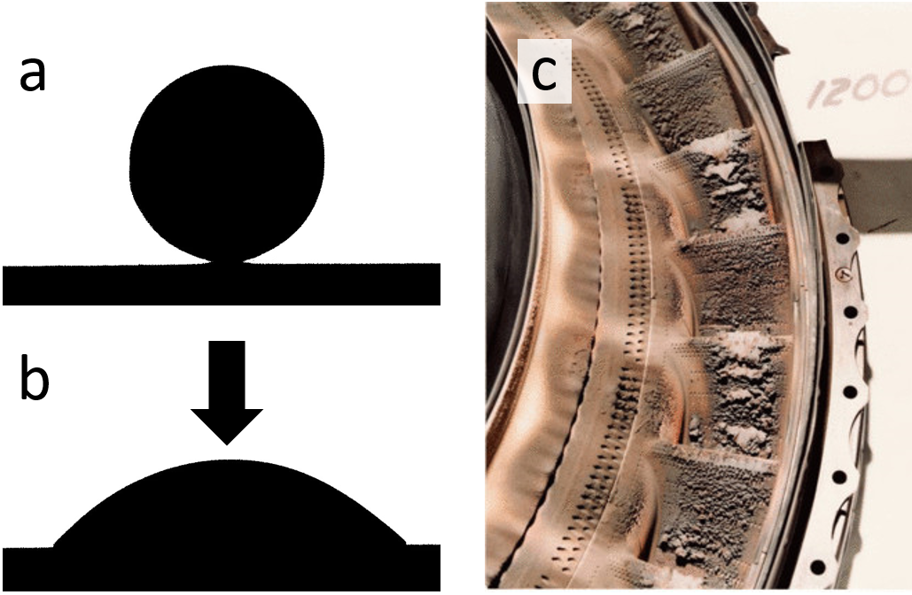
Figure 1: a) and b) 6mm diameter molten silicate droplet spreading on a turbine ceramic, imaged using an optical dilatometer in Earth Sciences hot lab. c) Ash deposition on jet engine interior following ash ingestion (flight BA009, 24th June, 1982)
Molten ash particles have viscosities of 10⁶ – 10¹² Pa.s and impact jet engine surfaces at velocities of hundreds of m/s. The impacts are therefore in a regime that has not previously been investigated: viscoelastic rheology, high Weber number, and high Ohnesorge number. The bouncing, sticking, and spreading behavior of highly viscous droplets impacting a surface at high velocity is therefore a frontier topic in soft matter science. We will use laboratory experiments (Figure 1) and theoretical analysis to investigate the conditions under which molten glass droplets bounce off, stick to, and spread across hot surfaces. Experiments will exploit a new, state-of-the-art ‘hot lab’ in Earth Sciences, using optical dilatometry, high temperature rheometry, and laser particle size analysis. The study will draw on the extensive literature on industrially-relevant droplets (e.g. spray coating, inkjet printing) and extend it to regimes relevant to jet engine interiors. A fundamental new contribution will be to investigate regimes where viscoelastic behavior giving rise to elastic bouncing at high impact velocity is important.
The new, quantitative understanding of droplet behaviour that this project will produce will support work by project partner Rolls-Royce to determine critical conditions of atmospheric ash loading and ash characteristics (shape, composition, size distribution) beneath which airspace can remain open.
Training:
The student will receive additional training, beyond the SOFI training, through four main routes:
1. As part of the Durham Volcanology Group you will receive training in reading and writing academic papers, presentation skills, preparation of figures, and grant writing, in addition to seminars, discussion sessions, fieldtrips and other activities.
2. The student will receive bespoke training in experimental techniques including high temperature rheometry, optical dilatometry, particle size analysis, and impact experiments, all to be undertaken in the new ‘hot lab’ in Earth Sciences. The supervisory team will also provide training in relevant analytical, mathematical, and numerical techniques.
3. The industrial partner, Rolls-Royce, will provide support in analysis and modelling of data, and will host the student for periods of industrial experience.
4. The project aligns with an IAS major project funded for 2020/21, “The global risk of volcanic eruptions to the airline industry”, led by the supervisory team. This will embed the student in a larger project that includes partners in the airline industry and aviation policy.

