Synthetic Polymer Networks with Dynamic Topologies
Dr Paul McGongial (Durham University)

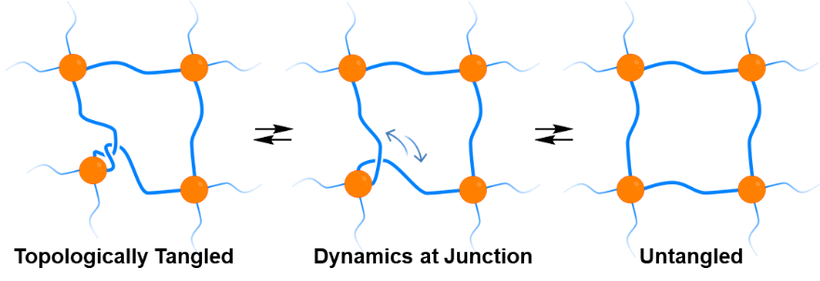
Cross-linked polymers are an important class of materials. Typically, they have fixed connectivities (links between crosslinking ‘nodes’) and fixed topologies (how neighbouring strands are wrapped around one another). This synthetic organic project in the McGonigal Group will develop the chemistry of structurally dynamic nodes, which will give cross-linked polymers dynamic topology without the need for the covalent connections in the network to be broken. The aim is to synthesise this new class of materials and investigate the resulting properties. Our hypothesis is that the unusual topological dynamics will impart low elastic moduli and high yield strength, giving rise to robust but flexible materials.

The student will synthesise dynamic cross-link building blocks that can be polymerised to form cross-linked networks. Polymerisation with, for example, polyethylene glycols of different lengths will give a series of cross-linked polymers, which we expect to be hydrogels. Importantly, however, as the project is aimed towards a novel overarching concept rather than a specific target, the student will be able to develop a wide range of materials with differing properties using other bond forming chemistries and polymeric linkers. The student will use TEM, SEM and SAXS to characterise the polymer morphology. They will then probe the new topological dynamics using microrheology experiments to quantify the elastic storage and loss moduli, as well as the frequency dependences using SOFI²’s collaborative links.

