Rational Design of Antimicrobials from Self-Assembling Peptoids
Dr. Anders Aufderhorst-Roberts, Prof. Steven Cobb
Antibiotic resistance poses an imminent threat to global health, necessitating the development of innovative approaches to combat microbial infections. This exciting project focuses on harnessing the power of short peptide molecules with established antimicrobial properties. Recent advances have revealed the remarkable antimicrobial activity of self-assembled supramolecular structures formed by simple two-to-three amino acid sequences. This project aims to design an antimicrobial system capable of toggling between active and inactive states through macromolecular assembly and disassembly.
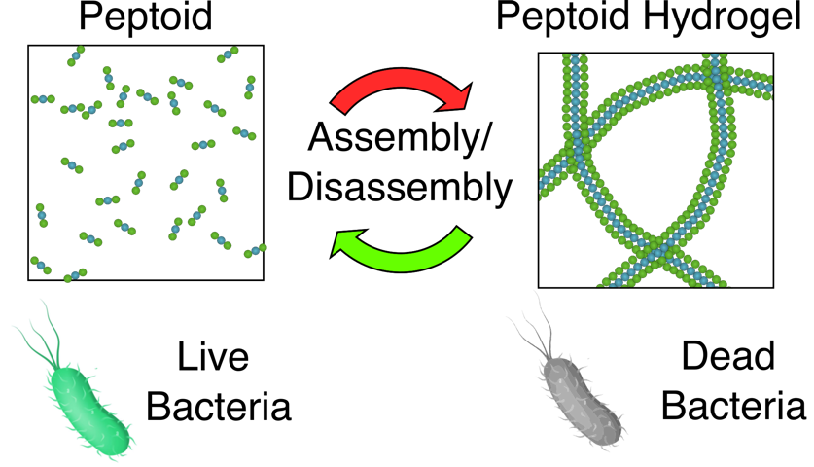
The project goals are to rationally design peptoids that can controllably self-assembled and disassembled through in environmental triggers. Antimicrobial function for such systems typically only manifests in the assembled state, allowing for controllable antimicrobial function.
In this project, you will work with small molecules to construct novel switchable antimicrobial materials. Recognizing the limitations of peptides as drug candidates due to their vulnerability to proteolytic degradation, we will instead explore the potential of peptide analogs called peptoids. Your primary objective will involve devising effective strategies to assemble these peptoids into supramolecular hydrogels, leveraging various external stimuli such as light, ionic strength, pH, and chemical triggers. To evaluate and characterize the resulting peptoid hydrogels, you will employ advanced microrheology techniques. Using recent advances in microrheology instrumentation you will measure the hydrogel viscoelasticity by analyzing rotational diffusion of embedded particles and fluorescence polarization using a multi-well plate reader. This high-throughput methodology requires minimal sample volumes, offers an ideal platform for thorough exploration of a wide compositional parameter space.
Once promising candidate peptoids are identified, you will delve into the intricate kinetics of assembly and disassembly. Employing microfluidic devices, you will investigate the triggers responsible for peptoid assembly and disassembly, ensuring precise control over their switchable properties. In the final phase of the project, you will collaborate with clinical partners at Queens University Belfast to assess the effectiveness of the self-assembled peptoids. Working closely with the clinical collaborators, you will expose E.coli bacteria to both peptoid monomers and supramolecular hydrogels, elucidating their antimicrobial activity and potential for clinical applications.

