Controlled Synthesis of Sustainable Block Copolymer Compatibilizers
Dr Jennifer Garden
University of Edinburgh
Plastics are both a friend and foe of the environment. Plastic materials provide significant advantages in terms of reducing food waste, reducing greenhouse gas emissions through their use as lightweight components in transport vehicles, and reducing energy consumption through their use as building insulation. Plastics are also key components of sustainable technologies including wind turbines, lithium ion batteries and electric vehicles. Yet plastic materials have led to significant environmental pollution, and the majority are currently prepared from unsustainable petrochemical sources. Therefore, it is essential to develop a range of sustainable alternatives to conventional plastics, which can be made from biomass and recycled or degraded after use.
Aliphatic polyesters are an attractive class of sustainable materials, as polymers such as poly(lactic acid) can be derived from biomass and are biodegradable. However, the range of applications of aliphatic polyesters is currently limited by their material properties. The formation of polymer blends (combining two different types of polymer) is an attractive method of adapting the material properties and thus expanding the range of applications. However, the different polymer components can phase separate leading to poorer properties; this can be overcome by using a compatibilizer. This project will focus on developing block copolymers as compatibilizers to form polymer blends with a range of properties.
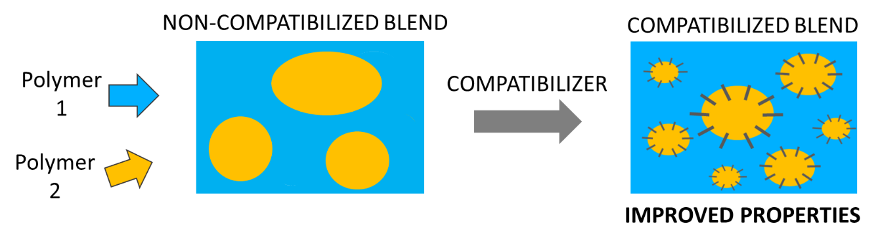
The preparation of the targeted block copolymer compatibilizers requires careful catalytic control over the polymer synthesis and architecture. By using organometallic catalysis to carefully control the polymer microstructure (M_{n}, dispersity, stereochemistry, selectivity and copolymer architecture), a broad range of block copolymers will be synthesised and characterised. These block copolymers will be subsequently be tested and evaluated as compatibilizers for polyester blends to understand the impact on the material properties.
This project encompasses a range of high-level polymer synthesis and characterization techniques. Polymer synthesis will be performed using gloveboxes and Schlenk lines, whilst the characterization will include NMR spectroscopy (including DOSY), mass spectrometry and size exclusion chromatography. The compatibilized polymer blends will be analyzed using a range of techniques, including tensile testing and microscopy (SEM, TEM) to determine phase separation.

